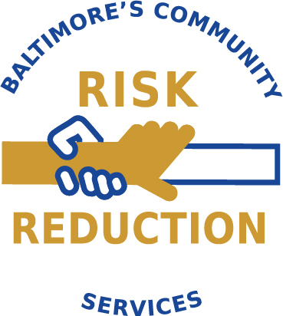
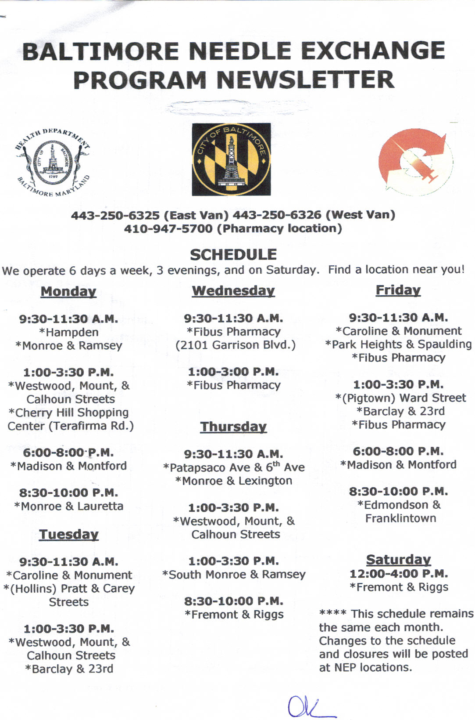
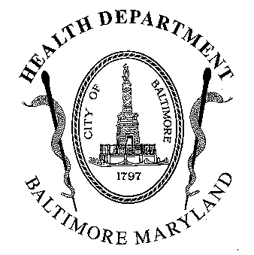BALTIMORE NEEDLE EXCHANGE PROGRAM NEWSLETTER

Spring / Summer 2016

East Van: 410-371-2596 West Van: 410-371-2547
Community Risk Reduction Services Management Team-
Derrick Hunt, Jeffrey Long and Lisa Parker 410-396-3731
Monday  9:30 a.m. – 11:30 a.m.  Monroe & Ramsey  Greenmount & Preston  12:45 p.m. - 3:30 p.m.  Baker & Fulton  Pontiac & 9th  6:00pm -8:00pm  Baltimore & Conkling  (Highlandtown)  8:30pm- 10:00pm  Milton & Eager  Tuesday  9:30 a.m. - 11:30 a.m.  Montford & Biddle  Pratt & Carey  12:45 p.m. - 3:30 p.m.  Freemont & Riggs  Barclay & 23rd  Like us on  | Wednesday  6:00 p.m. – 8:00 p.m.  Baltimore & Conkling  (Highlandtown)  8:30 p.m. – 10:00 p.m.  Fremont & Laurens  Thursday  9:30 a.m. – 11:30 a.m.  Pontiac & 9th Ave.  North & Rosedale  12:45 p.m. – 3:30 p.m.  Park Heights & Classen  Monroe & Ramsey  *Baltimore & Gay (The Block)  7:00 pm - 10:00 pm  Services offered on The Block:  Overdose Prevention  (Every Thursday)  Baltimore Health Care Access  (Every Thursday)  Reproductive Health Services:  Contraceptive Services  Emergency Contraception  STD Testing &Treatment  Pregnancy Testing  Referrals to Prenatal Care  Referrals to JHU CAP Program  Pap Smears  *Reproductive Health Services are provided every Thursday. | Friday  9:30 a.m. – 11:30 a.m.  Park Heights & Spaulding  TBD- call office  12:45 p.m. – 3:30 p.m.  Baker & Fulton  Barclay & 23rd  6:00 p.m. – 8:00 p.m.  Montford & Biddle  8:30 p.m. – 10:00 p.m.  Monroe & Ramsey  Saturday  12:00 p.m. - 4:00 p.m.  Freemont & Riggs
Wound Care clinic

Currently on hold

See Staff for Referral Locations

NEP SCHEDULE:
Please Note: The Needle Exchange Program Will be closed on the Following Dates:

Monday July 4- Independence Day Monday September 30th- Labor Day

HOW TO BECOME A PARTICIPANT OF NEEDLE EXCHANGE

The Needle Exchange Program is an HIV and Hepatitis C prevention program that offers intravenous drug users risk reduction education and clean syringes to reduce the spread of HIV/AIDS and other infectious diseases. The program also provides access to drug treatment. To become a participant of the Needle Exchange Program all you need to do is register at any of our locations. The participant must be an injection drug user. This program is free and confidential. No identification is required for registration.
RULES FOR NEEDLE EXCHANGE CLIENTS |  | DRUG OVERDOSE PREVENTION AND RESPONSE TRAINING
- Respect other clients, the staff, and the neighborhoods that the NEP operates in.  - Never expose needles outside of the van or pharmacy.  - No soliciting of any kind on the van or outside of the van.  - Recap all  Syringes.  - Do not break the points off the syringes. | - Please do not pass syringes to other clients in the line to exchange on your behalf.  - Please do not consume alcohol beverages or use any drugs in line or while being serviced.  - Please no loitering or littering around needle exchange sites.  - Please do not make any money transactions in the line or around the van while waiting to exchange.  - Please do not bundle or unbundle syringes while on the van | Do you know how to decrease your chance of overdosing or assist someone who has overdosed?  If not, you can get training at our drug overdose prevention program.  Training Schedule:  University of Maryland Methadone Clinic:  TBD  Next Passage Treatment Center:  First Monday of each month – 12:00 noon  Glenwood Life Methadone Clinic:  Second and Third Monday of each month – 12:00 pm  Other treatment-based training locations include:  *Man Alive *New Hope *Dee’s Place *ADAPT *Reflective  * Trainings are held on a regular basis on the NEP mobile units, and usually take about 10 minutes to complete. Each person trained will receive an overdose response kit, which includes naloxone. If you are interested, please ask a health educator about details and availability. We strongly encourage everyone to take the training.  For more information call The Staying Alive Program Coordinator, Thomas Clemons at 410-829-9480
The Baltimore City Needle Exchange Program has transitioned to a needs-based distribution model. Using this approach, we strive to provide an adequate level of safe injection equipment to all participants based upon their individual need and our program protocol.

INTERESTED IN DRUG TREATMENT?
HOW TO OBTAIN A DRUG TREATMENT SLOT: We give out slots on a first come, first serve basis. Please come early to a site, and ask a Health Educator about openings upon entering location. We will try to make a referral or assist you with obtaining a referral from another source. Remember; try not to get frustrated—we want to help you get into treatment.
There Are different types of treatment slots available, and supportive housing assistance for those currently in treatment Through The NEP May Also Be Available
Vaccine Clinic
The Needle Exchange will be conducting a mobile vaccine clinic that will be providing Hepatitis B vaccines as well as Influenza at the following sites:

Baltimore & Gay, Monroe & Ramsey, Fremont & Riggs and Baltimore & Conkling

Please ask a Health Educator or call one of the numbers at the top of this newsletter, if you have questions

