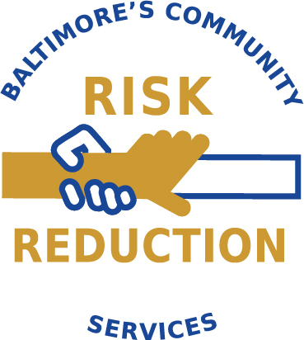
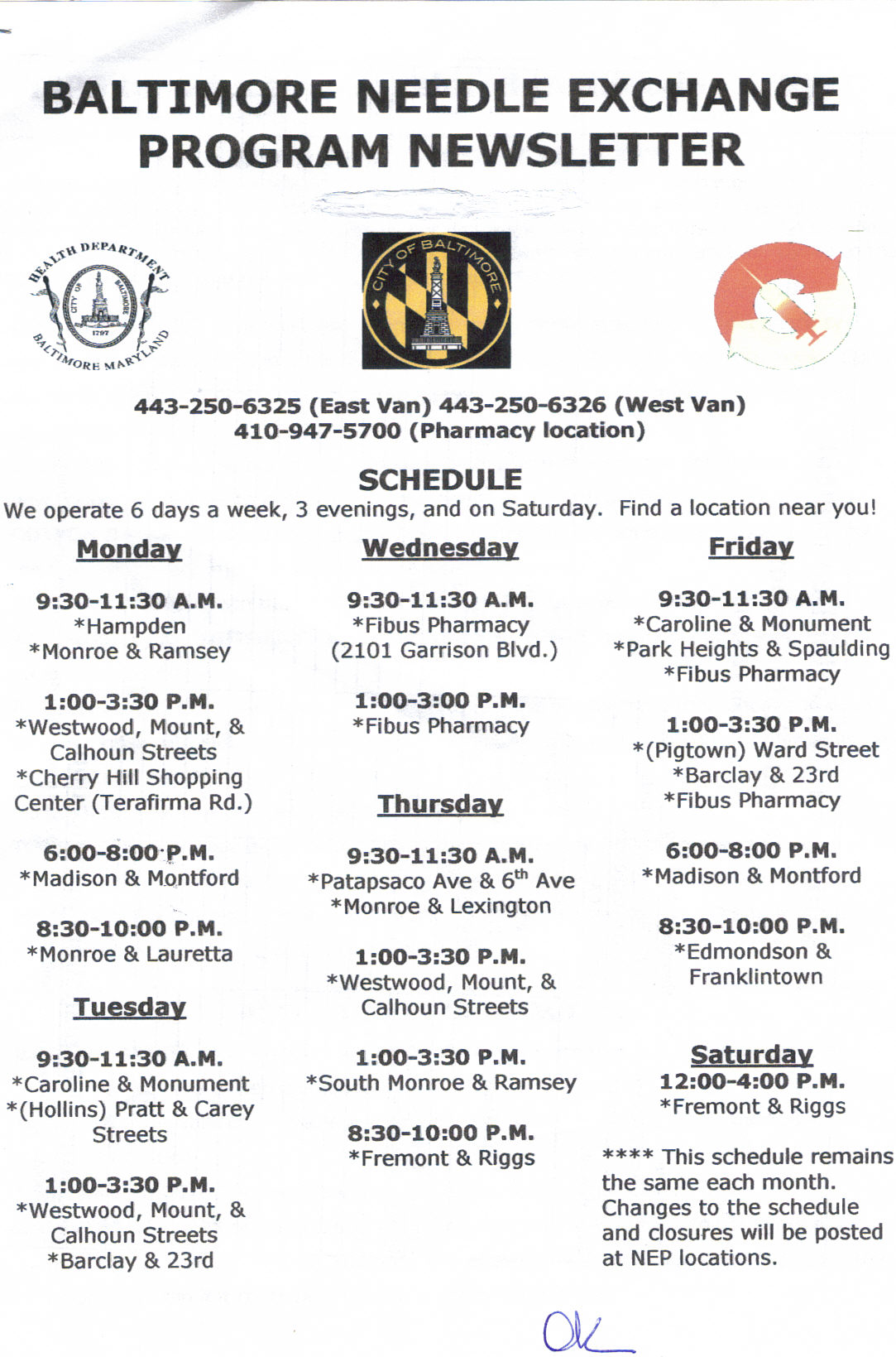
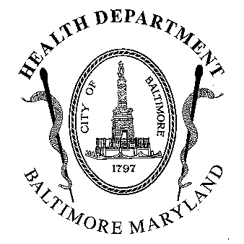BALTIMORE NEEDLE EXCHANGE PROGRAM NEWSLETTER

Summer 2014

East Van: 410-371-2596 West Van: 410-371-2547
Community Risk Reduction Services Management Team-Derrick Hunt and Jeffrey Long, 410-396-3731
Monday  9:30 a.m. – 11:30 a.m.  *Monroe & Ramsey  12:45 p.m. - 3:30 p.m.  *Westwood, Mount &  Calhoun Streets  3:30 p.m. – 4:45 p.m.  *Park Heights & Spaulding  6:00 p.m. - 8:00 p.m.  *Baltimore & Conkling  (Highlandtown)  8:30 p.m. - 10:00 p.m.  *Freemont & Laurens  Tuesday  9:30 a.m. - 11:30 a.m.  *Montford & Biddle  * Pratt & Carey  12:45 p.m. - 3:30 p.m.  *Freemont & Riggs  *Barclay & 23rd  Wednesday  3:30 p.m. – 4:45 p.m.  *Monroe & Ramsey  Like us on  | Wednesday-cont.  6:00 p.m. – 8:00 p.m.  *Baltimore & Conkling  (Highlandtown)  8:30 p.m. – 10:00 p.m.  *Fremont & Laurens  Thursday  9:30 a.m. – 11:30 a.m.  *Pontiac & 9th Ave.  *North & Rosedale  12:45 p.m. – 3:30 p.m.  * Ward Street  *Monroe & Ramsey  *Baltimore & Gay (The Block)  7:00 pm - 10:00 pm  *Services offered on The Block:  Overdose Prevention  (Staying Alive-every 2nd Thursday)  Baltimore Health Care Access  (Every Thursday)  Reproductive Health Services:  *Contraceptive Services  *Emergency Contraception  *STD Testing &Treatment  *Pregnancy Testing  *Referrals to Prenatal Care  *Referrals to JHU CAP Program  *Pap Smears  *Reproductive Health Services are provided every Thursday. | Friday  9:30 a.m. – 11:30 a.m.  *Park Heights & Spaulding  12:45 p.m. – 3:30 p.m.  *Westwood, Mount &  Calhoun Streets  3:30 p.m. – 4:45 p.m.  *Barclay & 23rd  6:00 p.m. – 8:00 p.m.  *Montford & Biddle  8:30 p.m. – 10:00 p.m.  *Monroe & Ramsey  Saturday  12:00 p.m. - 4:00 p.m.  *Freemont & Riggs
Wound Care Clinic
*Baltimore and Conkling-
Mondays
*Fremont and Riggs-
Tuesdays

See schedule for details
Bon Secours

If you Need mental health services, we can help. Social workers are available at:

Monroe & Ramsey on Thursdays.

NEP SCHEDULE: 
PLEASE NOTE: The Needle Exchange will be closed on the following dates:
May 26th, 2012- Memorial Day
July 4th, 2012- Independence Day
September 1st, 2012- Labor Day
HOW TO BECOME A PARTICIPANT OF NEEDLE EXCHANGE

The Needle Exchange Program is an HIV and Hepatitis C prevention program that offers intravenous drug users risk reduction education and clean syringes to reduce the spread of HIV/AIDS and other infectious diseases. The program also provides access to drug treatment. To become a participant of the Needle Exchange Program all you need to do is register at any of our locations. The participant must be an injection drug user. This program is free and confidential. No identification is required for registration.
RULES FOR NEEDLE EXCHANGE CLIENTS |  | DRUG OVERDOSE PREVENTION AND RESPONSE TRAINING
- Respect other clients, the staff, and the neighborhoods that the NEP operates in.  - Never expose needles outside of the van or pharmacy.  - No soliciting of any kind on the van or outside of the van.  - Recap all  Syringes.  - Do not break the points off the syringes. | - Please do not pass syringes to other clients in the line to exchange on your behalf.  - Please do not consume alcohol beverages or use any drugs in line or while being serviced.  - Please no loitering or littering around needle exchange sites.  - Please do not make any money transactions in the line or around the van while waiting to exchange.  - Please do not bundle or unbundle syringes while on the van | Do you know how to decrease your chance of overdosing or assist someone who has overdosed?  If not, you can get training at our drug overdose prevention program.  Training Schedule:  University of Maryland Methadone Clinic:  First Wednesday of each month – 1:00 pm  Next Passage Treatment Center:  First Monday of each month – 9:00 am  Glenwood Life Methadone Clinic:  Second Monday of each month – 12:00 pm  *There are other training locations that are not listed above because they are not regularly scheduled, so please contact the program coordinator if you have any questions.  *Man Alive  *New Hope  *IBR Reach  *Dee’s Place  *Recovery Network  *HRC Shelter (The Fallsway)  For more information call the Staying Alive Program Coordinator, Thomas Clemons at 443-829-9480

INTERESTED IN DRUG TREATMENT?
HOW TO OBTAIN A DRUG TREATMENT SLOT: We give out slots on a first come, first serve basis. Please come early to a site, and ask a Health Educator about openings upon entering location. We will try to make a referral or assist you with obtaining a referral from another source. Remember! try not to get frustrated—we want to help you get into treatment.
There Are different types of treatment slots available, and supportive housing assistance for those currently in treatment through the nep
Vaccine Clinic
The Needle Exchange will be conducting a mobile vaccine clinic that will be providing Hepatitis B vaccines as well as Influenza at the following sites:

Baltimore & Gay, Monroe & Ramsey, Fremont & Riggs, Park Heights & Spaulding

Please ask a Health Educator or call one of the numbers at the top of this newsletter, if you have questions

