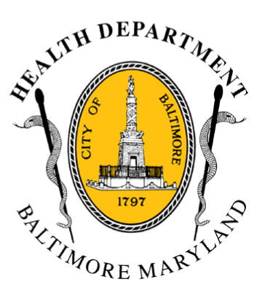

BCHD PRESS RELEASE
Baltimore City Health Department
1001 E. Fayette Street • Baltimore, Maryland 21202
Stephanie Rawlings-Blake, Mayor
Leana Wen, M.D., Commissioner of Health

FOR IMMEDIATE RELEASE
Media Contact: Michael Schwartzberg, PIO
O: (443) 984-2623 C: (443) 462-7939 E: michael.schwartzberg@baltimorecity.gov

Health Department Announces OneBaltimore / Baltimore Corps Team To Lead Department’s Public Health Recovery Efforts

BALTIMORE, MD (June 2, 2015) – In response to the recent civil unrest in Baltimore, the Baltimore City Health Department announces the selection of a team of fellows to lead the agency’s public health recovery efforts under Mayor Stephanie Rawlings-Blake’s OneBaltimore initiative.

The team was hired as part of Baltimore Corps (http://www.baltimorecorps.org), a nonprofit that connects Baltimore’s future leaders with organizations working to make the city a better place. The team of fellows is charged with engaging the community and with planning and implementing programs aimed at addressing priorities identified by the community.

“The root causes of Baltimore’s unrest have their foundation in underlying health disparities,” said Dr. Leana Wen, Baltimore City Health Commissioner. “These problems have taken decades to build, but we have a real opportunity right now to tackle these problems and help our city become a successful and positive model for others around the country. The fellows will play a key role to catalyze and jumpstart our public health recovery work.”

The fellows bring diverse expertise that include backgrounds in community organizing and engagement, public health, and social entrepreneurship, and they have experience working with some of Baltimore’s most at-risk residents and vulnerable populations around the world.

Sarah Ceponis has extensive experience in outreach and public health, including in West Baltimore; Wes Williams is a social entrepreneur who has focused much of his career on innovative ways that business can serve at-risk communities; and Kelleigh Eastman is an experienced community organizer in public health who has experience across Baltimore.

- more -

2-2-2

The team will use their skills and experiences to convene community meetings and to think strategically with community leaders and residents on critical issues. They will plan programs to address these issues and secure funding from public and private partners to implement them.

“We are thrilled to partner with the Health Department,” said Fagan Harris, CEO and Co-Founder of Baltimore Corps. “Under Dr. Wen’s leadership, this team of fellows will be uniquely positioned to have a significant, lasting, and positive impact on this city.” Funding for the three fellows is provided in part by a private philanthropist and the de Beaumont Foundation is also enthusiastic about supporting our fellows.

“The OneBaltimore efforts we’ve launched in recent weeks are designed to encourage exactly this kind of creative thinking to addressing the underlying problems in Baltimore,” said Mayor Rawlings-Blake. “The Health Department has embodied the spirit of OneBaltimore in coming up with this innovative solution, and I look forward to continuing to support their work as we work to heal and strengthen our city.”

###

